**Your Name: Purnabhishek Sripathi**

**Grading Policy: In order to get credit for each screenshot,** you **MUST** have the repository named as ***BAN540_YourLastName (you should see your own last name)*** with ***Chapter04DataSet_YourLastName*** and ***BAN540_Lab2_YourLastName*** in it. The repository and data files **MUST** be clearly shown in your screenshots as my examples below. If not, you will get ZERO for that particular screenshot which doesn’t show it clearly.

**Screenshot #1: The Main Process for Correlation Matrix Calculation (3 points)**

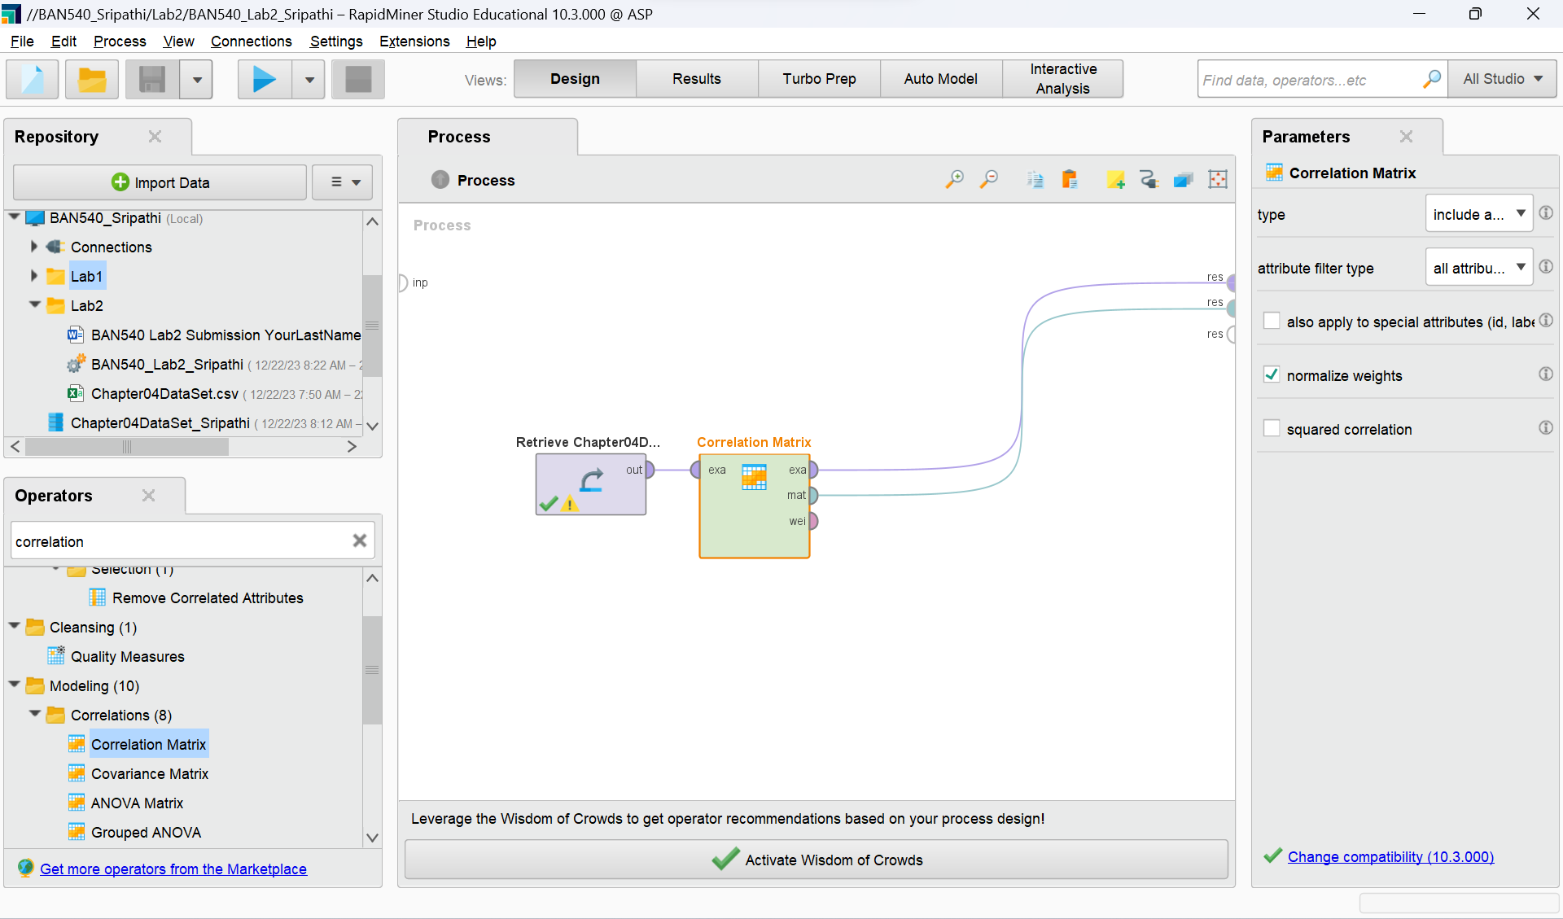

**Screenshot #2: Correlation Matrix Result (3 points)**

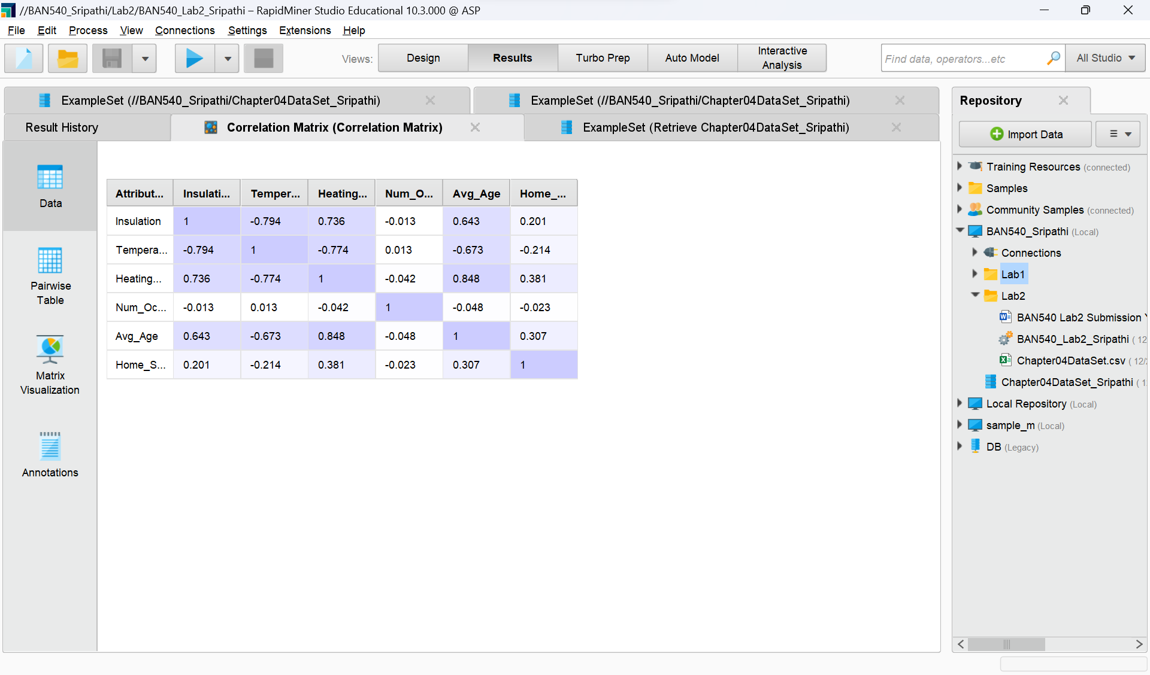

**Screenshot #3: Scatter Chart (4 points)**

**Screenshot #4: Scatter 3D Color Chart (5 points)**

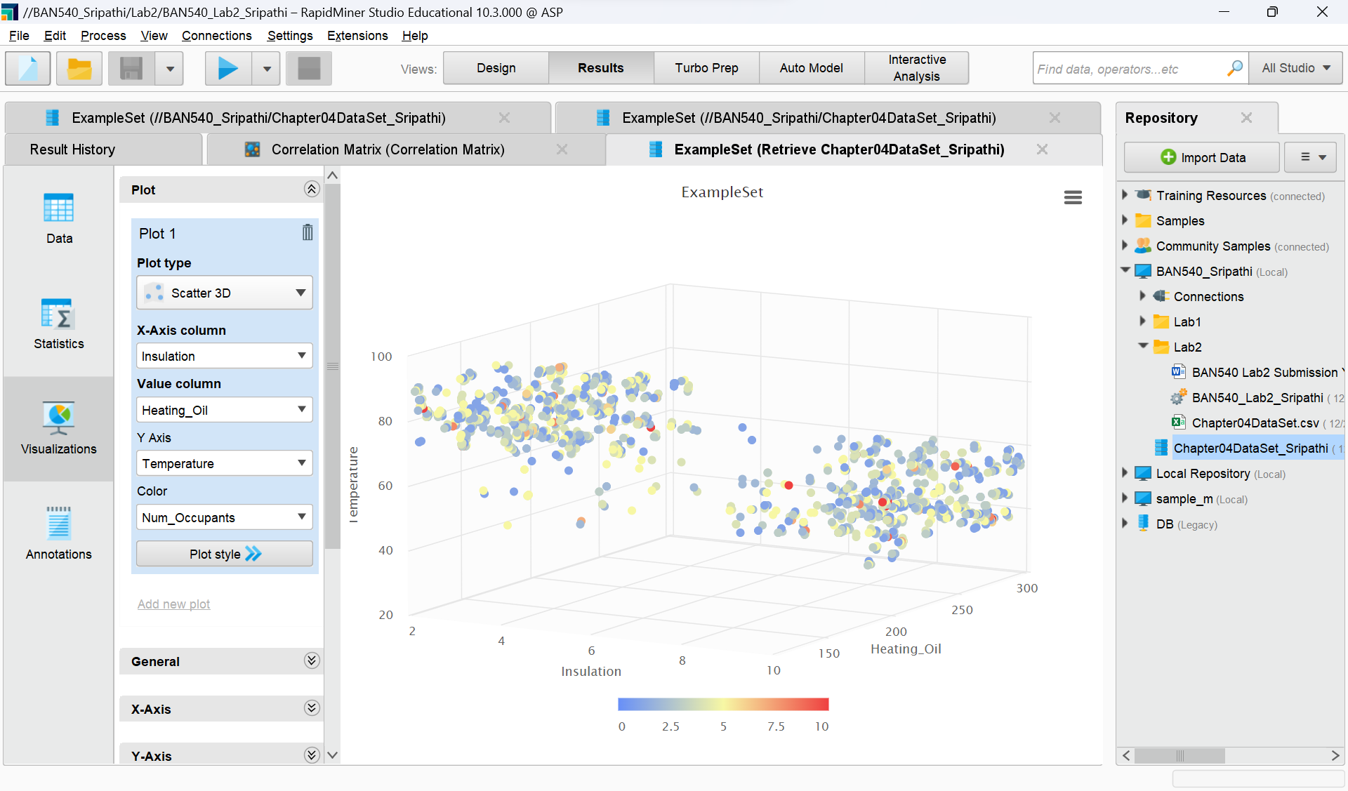

**Screenshot #5: Boxplot (5 points)**

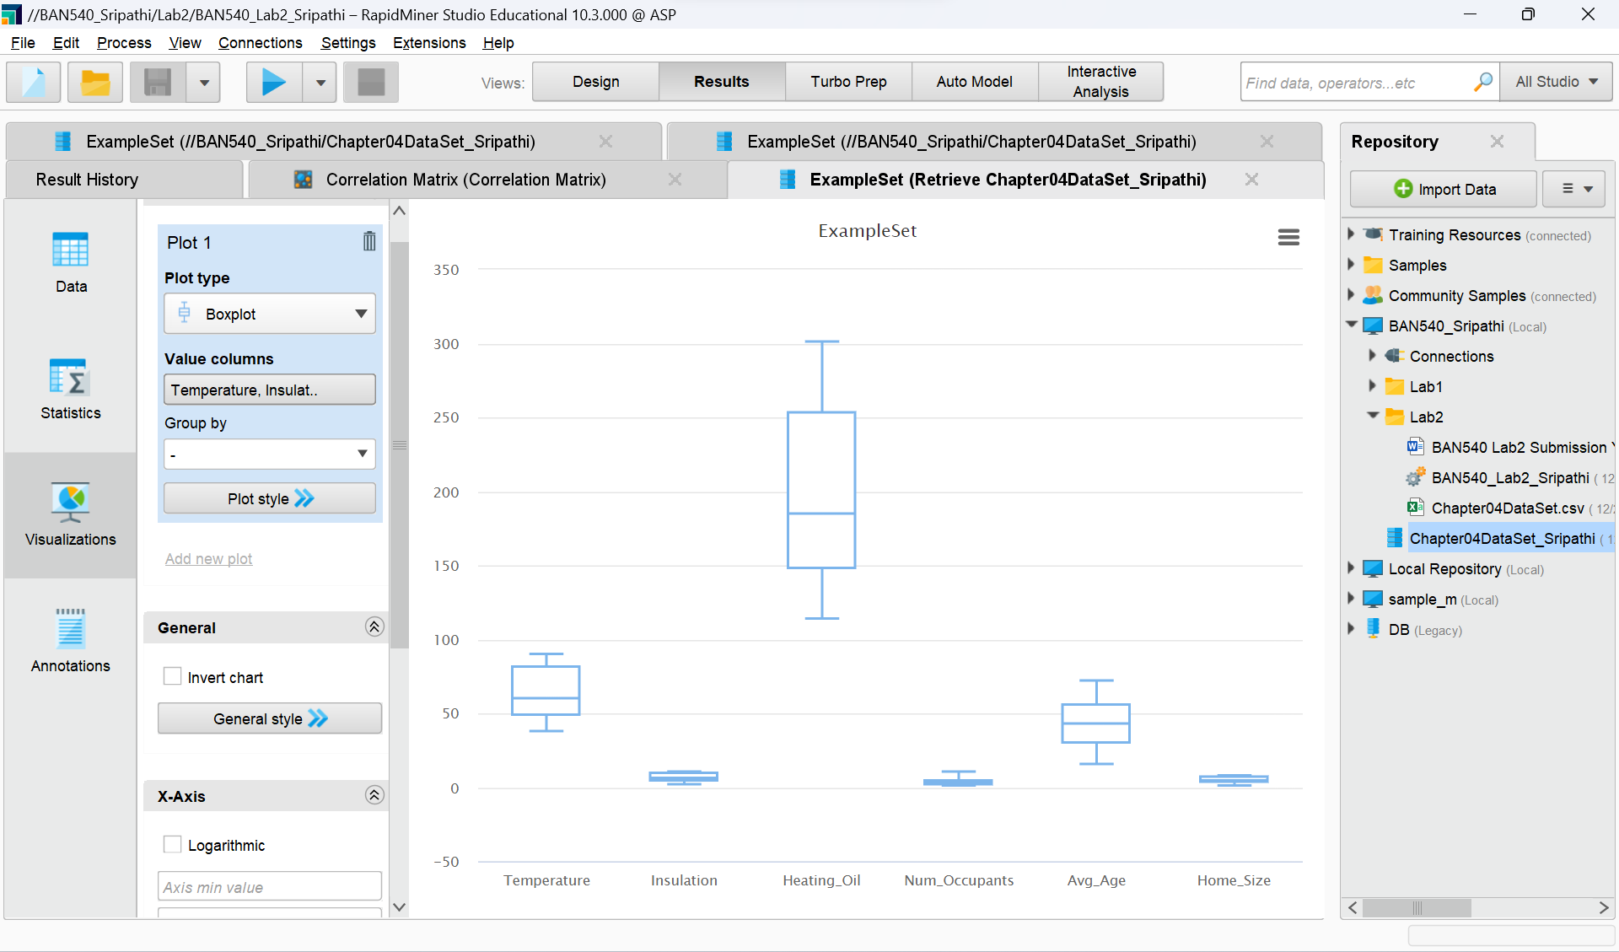

**Screenshot #6: Scatter Multiple (5 points)** 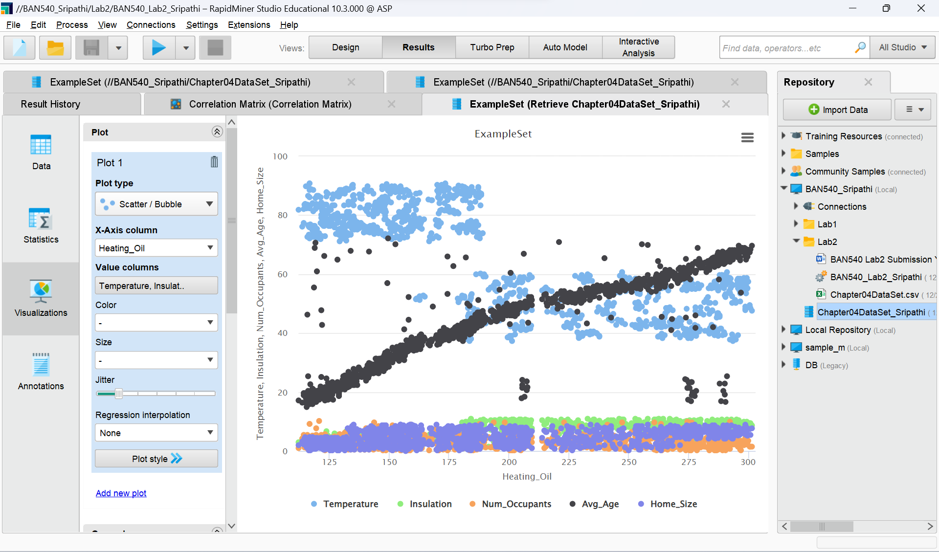

**Screenshot #7: Scatter Matrix (5 points)**

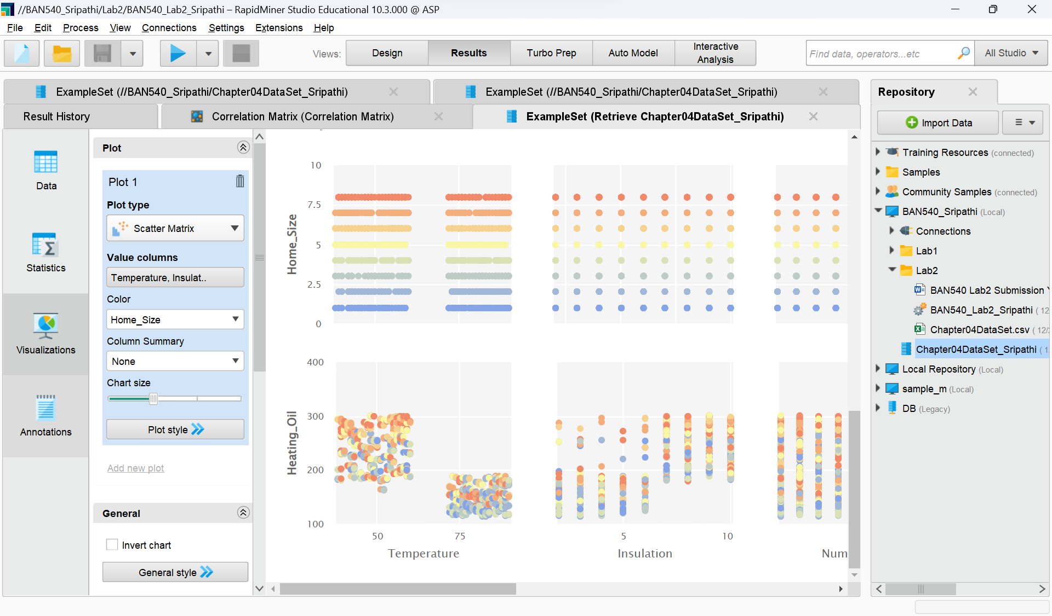

**Now you are done with Lab Assignment 2, please make sure to type in your name on the first page of this document, and rename this document to reflect your own last name before submitting it to Canvas.**